Lab#7: Interrupt Instructions (Part B)

Assignment #1: Write an assembly code to display ‘Assembly’ message, then moving down the message until reach the end of the screen

Solution:

Assignment #2: Write an assembly code to do the following:
- Display a message "enter 4 characters: ' in the screen.
- Accept the 4 characters from the keyboard.
- Clear the screen.
- Display the 4 characters at the center of the screen, then display the characters as follows:
Example: if the user input: ABCD, the display must be as the following figure

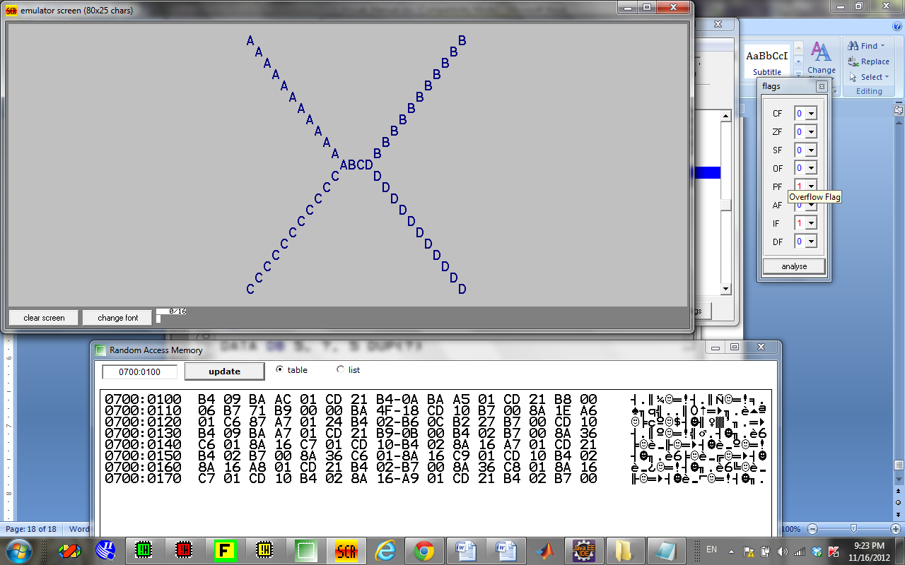

Assignment #3: This example prints out “hello world!" by writing directly to video memory.
In VGA memory: first byte is ASCII character, byte that follows is character attribute. If you change the second byte, you can change the color of the character even after it is printed. The character attribute is 8 bit value; high 4 bits set background color and low 4 bits set foreground color.

HEX BIN COLOR
------------------------------------------------------
0 0000 black
1 0001 blue
2 0010 green
3 0011 cyan
4 0100 red
5 0101 magenta
6 0110 brown
7 0111 light gray
8 1000 dark gray
9 1001 light blue
A 1010 light green
B 1011 light cyan
C 1100 light red
D 1101 light magenta
E 1110 yellow
F 1111 white

Solution:

